Assignment 4

Arjen van der Meer

# BFS

1:

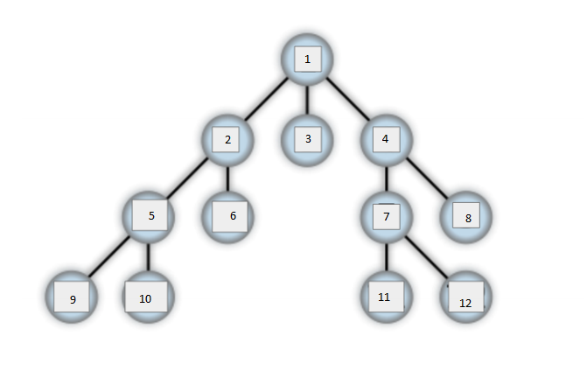

2: See application

3:

|  |  |  |
| --- | --- | --- |
| step | queue | Processed |
| 0 | A |  |
| 1 | BDE | A (1) |
| 2 | DEC | B (2) |
| 3 | EC | D (3) |
| 4 | CF | E (4) |
| 5 | F | C (5) |
| 6 | GH | F (6) |
| 7 | H | G (7) |
| 8 |  | H (8) |

So: ABDECFGH

is the list of visited nodes

# DFS

1.

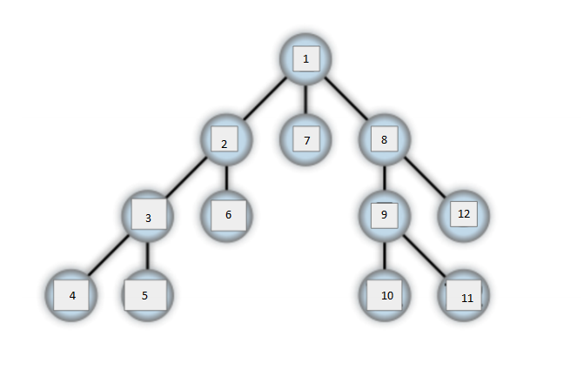

2: See application

3:

|  |  |  |
| --- | --- | --- |
| step | Stack | Processed |
| 0 | A |  |
| 1 | BDE | A (1) |
| 2 | BDF | E (2) |
| 3 | BDGH | F (3) |
| 4 | BDG | H (4) |
| 5 | BD | G (5) |
| 6 | B | D (6) |
| 7 | C | B (7) |
| 8 |  | C (8) |

So: AEFHGDBC

is the list of visited nodes